Ex. No: 2 SQL DML COMMANDS

**Date:**

**AIM:**

To write SQL queries to execute different DML commands.

Data base created for this exercise is:

SQL DML Commands-1.1 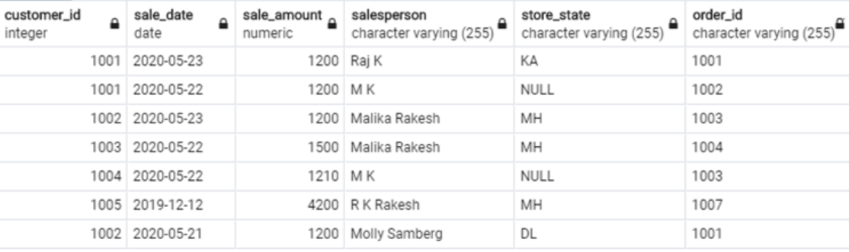

**DML Commands:**

* **SELECT -** Used to query or fetch selected fields or columns from a database table

Syntax,

SELECT column_name1, column_name2, …

FROM table_name

WHERE condition_ expression;

Example:

Select customer_id, sale_date, order_id, store_state from customers;

Select * from customers;

* **INSERT -** Used to insert new data records or rows in the database table

Syntax,

INSERT INTO table_name (column_name_1, column_name_2, column_name_3, ...)

VALUES (value1, value2, value3, ...)

Example:

INSERT INTO sales(

customer_id, sale_date, sale_amount, salesperson, store_state, order_id)

VALUES (1005,TO_DATE('2019-12-12','YYYY-MM-DD),4200,'R K Rakesh','MH','1007');

(or)

INSERT INTO customers

VALUES ('1006','2020-03-04',3200,'DL', '1008');

* **UPDATE -** Used to set the value of a field or column for a particular record to a new value

**Syntax,**

**UPDATE table_name**

**SET column_name_1 = value1, column_name_2 = value2, ...**

**WHERE condition;**

Example,

UPDATE customers

SET store_state = 'DL'

WHERE store_state = 'NY';

* **DELETE -** Used to remove one or more rows from the database table

**Syntax,**

**DELETE FROM table_name WHERE condition;**

Example,

DELETE FROM customers

WHERE store_state = 'MH'

AND customer_id = '1001';

**Result:**

Thus the DML commands are used to modify or manipulate data records present in the customer database tables.